FIRST PRESBYTERIAN CHURCH
3rd Sunday after Pentecost, 10:00 a.m. June 13, 2021

Prelude

Welcome and Announcements

Introit

Call to Worship Psalm 92
Leader: It is good thing to give thanks to the Lord, to sing praises to your name, O Most High;
People: to herald your love in the morning, and your faithfulness at night
Leader: on the psaltery, and on the lyre, and to the melody of the harp.
People: For you have made me glad by your acts, O Lord; and I shout for joy because of the works of your hands.
Leader: The righteous flourish like a palm tree, and shall spread abroad like a cedar of Lebanon.
People: Those who are planted in the house of the Lord shall flourish in the courts of our God.
Leader: they shall still bear fruit in old age; they shall be green and succulent;
All: that they may show how upright the Lord is, my rock, in whom there is no injustice.

Opening Prayer

*Opening Hymn “Come, Thou Almighty King” (see insert)

Prayer of Confession
Merciful God, in your gracious presence we confess our sin and the sin of this world. Although Christ is among us as our peace, we are a people divided as we cling to the values of a broken world. We believe we are one in Christ, but we set neighbor against neighbor and nation against nation. Lord, have mercy upon us; heal and forgive us. Set us free to serve you in the world as agents of your reconciling love in Jesus Christ.

Assurance of Pardon

*Gloria Patri
Glory be to the Father, and to the Son, and to the Holy Ghost. As it was in the beginning, is now and ever shall be, world without end, Amen.

We Hear God’s Word Proclaimed

Scripture Reading 1 Samuel 15:34 - 16:13

Special Music

Scripture Reading Mark 4:26-34

Sermon The Rev. Natasha Sudderth

Affirmation of Faith
I believe in God, the Father almighty, Maker of heaven and earth, and in Jesus Christ his only Son, our Lord; who was conceived by the Holy Ghost, born of the Virgin Mary, suffered under Pontius Pilate, was crucified, dead, and buried; he descended into hell; the third day he rose again from the dead; he ascended into heaven, and sitteth on the right hand of God the Father Almighty; from thence he shall come to judge the quick and the dead. I believe in the Holy Ghost; the holy catholic church; the communion of saints; the forgiveness of sins; the resurrection of the body; and the life everlasting. Amen.

Prayer of Intercession
Leader: Loving God, you cause rain to fall on the just and the unjust. Hear our prayers for your church and world: for the hungry and the overfed,
People: may we have enough;
Leader: for the mourners and the mockers,
People: may we laugh together;
Leader: for the victims and the oppressors,
People: may we share power wisely;
Leader: for the peacemakers and the warmongers,
People: may clear truth and stern love lead us to harmony;
Leader: for the silenced and the propagandists,
People: may we speak our own words in truth;
Leader: for the troubled and the secure,
People: may we live together as wounded healers;
Leader: for the vibrant and the dying,
All: may we all die to sin and live to love.

Prayers of the people and the Lord’s Prayer
Our Father who art in heaven, hallowed be Thy name. Thy kingdom come, Thy will be done, on earth as it is in heaven. Give us this day our daily bread; and forgive us our debts, as we forgive our debtors; and lead us not into temptation, but deliver us from evil. For Thine is the kingdom and the power and the glory, forever. Amen.

Offertory

*Doxology and Prayer of Dedication
Praise God from whom all blessings flow; praise God, all creatures here below; praise God above, ye heavenly host; praise Father, Son, and Holy Ghost. Amen.

*Sending Hymn “Rejoice, the Lord is King!” (see insert)

*Charge and Benediction

*Postlude

*Those who are able, please stand.

We warmly greet all who have come to worship God. Your presence will enhance our worship experience and our fellowship together. Sincere thanks to each of you for your participation in the service. Glory be to God!

Leading Worship: The Rev. Natasha Sudderth-Davis, Pastor; Susan Lincoln, liturgist; Bob Bell, Accompanist & Director; Rachel Poppell, Elder of the Month. Ushers for June 20th: Warren Gregory, Polly Kincaid, Cheryl Gregory, Betty Culbreath, Tuckie Maultsby, and Ron Poppell. Cover Image: Lefterov, Edal. White Mustard Seeds , from Art in the Christian Tradition, a project of the Vanderbilt Divinity Library, Nashville, TN.

Announcements
Monday Morning Yoga 10 am
Prayer Meeting Thursdays 9:30 am in the church office
June Intergenerational Sunday school 11 am.

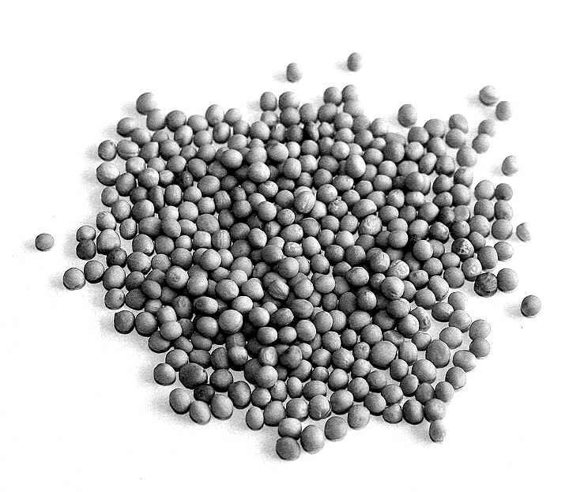

“White Mustard Seeds” by Lefterov, Edal

Come, Thou Almighty King
Come, Thou Almighty King, Help us Thy name to sing;
Help us to praise: Father, all glorious, O'er all victorious, Come, and reign over us, Ancient of Days.

Come, Thou Incarnate Word, merciful, mighty Lord,
Our prayer attend. Come, and Thy people bless, And give Thy Word success; Spirit of holiness, On us descend.

Come, Holy Comforter, Thy sacred witness bear In this glad hour. Thou who almighty art, Now rule in every heart, And ne'er from us depart, Spirit of power.

To thee, great One in Three, Eternal praises be, Hence evermore! Thy sovereign majesty May we in glory see,
And to eternity Love and adore.

Rejoice, the Lord is King!
Rejoice, the Lord is King! Your Lord and King adore!
Rejoice, give thanks, and sing, And triumph evermore. Lift up your heart; lift up your voice! Rejoice, again I say, rejoice!

Our Savior, Jesus, reigns, the God of truth and love; when he had purged our stains, he took his seat above. Lift up your heart; lift up your voice! Rejoice, again I say, rejoice!

His kingdom cannot fail; he rules o'er earth and heaven; the keys of death and hell are to our Jesus given. Lift up your heart; lift up your voice! Rejoice, again I say, rejoice!

Rejoice in glorious hope! For Christ, the Judge, shall come and gather all the saints To their eternal home.
Lift up your heart; lift up your voice! Rejoice, again I say, rejoice!
Come, Thou Almighty King
Come, Thou Almighty King, Help us Thy name to sing;
Help us to praise: Father, all glorious, O'er all victorious, Come, and reign over us, Ancient of Days.

Come, Thou Incarnate Word, merciful, mighty Lord,
Our prayer attend. Come, and Thy people bless, And give Thy Word success; Spirit of holiness, On us descend.

Come, Holy Comforter, Thy sacred witness bear In this glad hour. Thou who almighty art, Now rule in every heart, And ne'er from us depart, Spirit of power.

To thee, great One in Three, Eternal praises be, Hence evermore! Thy sovereign majesty May we in glory see,
And to eternity Love and adore.

Rejoice, the Lord is King!
Rejoice, the Lord is King! Your Lord and King adore!
Rejoice, give thanks, and sing, And triumph evermore. Lift up your heart; lift up your voice! Rejoice, again I say, rejoice!

Our Savior, Jesus, reigns, the God of truth and love; when he had purged our stains, he took his seat above. Lift up your heart; lift up your voice! Rejoice, again I say, rejoice!

His kingdom cannot fail; he rules o'er earth and heaven; the keys of death and hell are to our Jesus given. Lift up your heart; lift up your voice! Rejoice, again I say, rejoice!

Rejoice in glorious hope! For Christ, the Judge, shall come and gather all the saints To their eternal home.
Lift up your heart; lift up your voice! Rejoice, again I say, rejoice!

